Intro: Nervous System
Bi.12 Name:____________________________________________
M.Johnston Block: _____ Date: __________________________

1) What is the difference between a nerve a nerve cell and a neuron?
Nerve cell:
Neuron:
Nerve:

2) There are three types of neurons. What are they?

3) Fill in the following table to identify the structure and function of each of the neuron types. Do not use the terms “periphery” or “CNS” when describing function. Instead, identify a specific receptor and/or effector [one has already been done for you].

Structure | Neuron name | Function
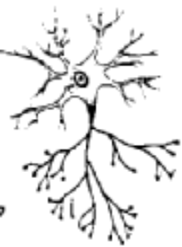
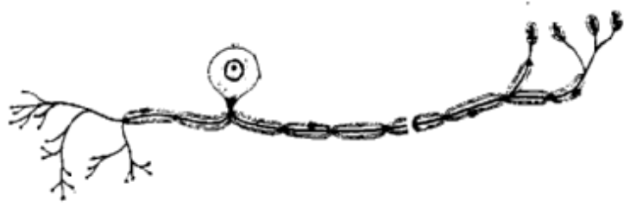 |  | Carry nerve impulses from the skin to the spinal cord.
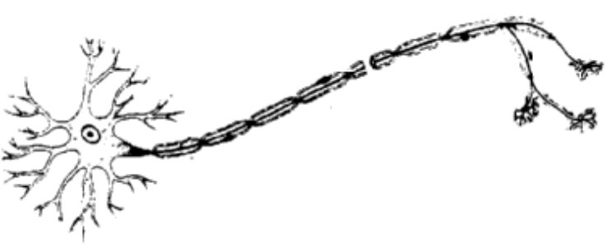

Over →
4) In each of the three figures above, label the dendrite, axon and cell body.

5) Draw arrows beside each neuron indicating the direction a nerve impulse would travel in this specific neuron.

6) What statement can you make about axon length versus dendrite length in

- Sensory neurons?
- Interneurons?
- Motor neurons?

****************************************

