**O. Excretory System**

***Chapter 16***

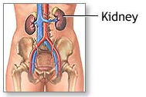**THE KIDNEY**

1. **Functions**
2. **Urine formation (to filter wastes from blood)**
3. **Maintain constant blood volume.**
4. **Maintain constant blood pH**
5. **Structures to know: On kidney picture** *Text p 306 & 305*
6. 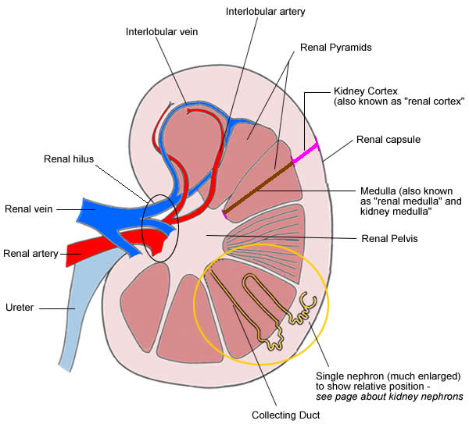**cortex**
7. **medulla**
8. **pyramid**
9. **renal pelvis**
10. **ureter**
11. **Renal artery**
12. **Renal vein**
13. **Hilus/hilum**
14. **Bladder**
15. **Urethra**

**Structures to know: On nephron picture**

1. **collecting duct**
2. **nephron**
3. **Bowman’s capsule**
4. **proximal convoluted tubule**
5. **loop of Henle**
6. **distal convoluted tubule**
7. **collecting duct**
8. **circulatory structures**
9. **renal artery**
10. **afferent arterioles**
11. **glomerulus**
12. **efferent arterioles**
13. **peritubular capillary network**
14. **renal vein**

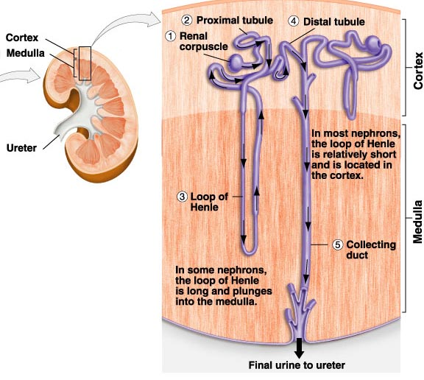

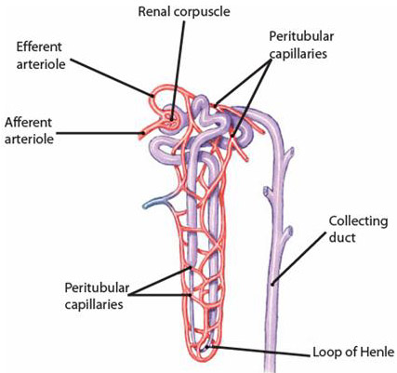

1. **Urine formation**
2. **Renal artery (entering kidney) branches into arterioles.**
3. **Afferent arteriole branches & divides to form a ball of capillaries.**

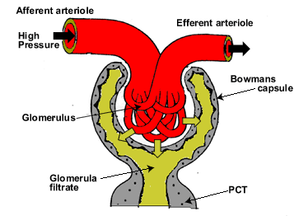

**🡪 this ball of caps. = glomerulus.**

**🡪 glomerulus fits inside Bowman’s capsule 🡪 it’s a funnel**

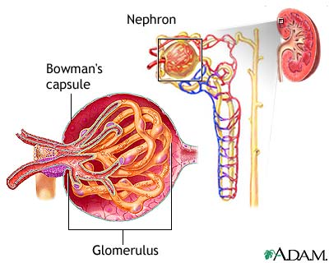

1. **blood pressure in glomerulus is higher than in normal capillaries. Due to:**
2. **Renal artery VERY short. (i.e. distance between heart and kidneys is short) so very little blood pressure lost.**

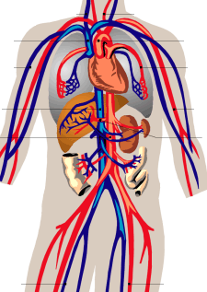

1. **Circumference of afferent & efferent arterioles can be varied (to increase or decrease blood pressure).**

1. **Juxtaglomerular apparatus (it can release the hormone renin which increases blood pressure.)**

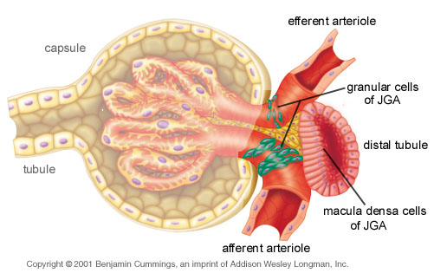

1. **Walls of glomerular capillaries are permeable to small molecules but not to large.**
2. **blood pressure (~ 60 mmHg) forces small molecules out of capillaries & into Bowman’s capsule.**

**🡪 E.g. H2O, glucose, salts, nutrients, & urea**

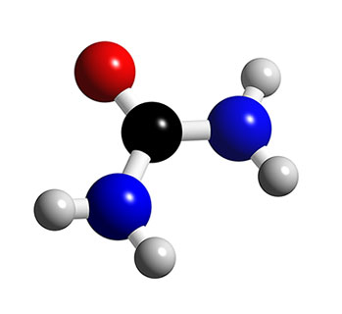

**🡪 Glomerular filtrate goes into proximal convoluted tubule.**

* **Glomerular filtrate … the fluid in the nephron tube … becomes urine.**

*Video of glomerular filtration. Weird [penguin], but good explanation.* [*http://www.youtube.com/watch?v=IWwftdhUslA*](http://www.youtube.com/watch?v=IWwftdhUslA)

1. **Blood cells, platelets, proteins & other large molecules stay in the glomerular capillaries & leave via efferent arteriole.**

**🡪 go to peritubular capillary network.**

1. **Proximal convoluted tubule.**

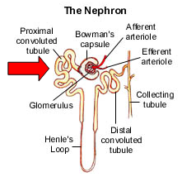

1. **Osmosis (of H2O) & diffusion (of small molecules) into cells lining wall of this tubule.**

**🡪 water then osmoses out of these cells & into capillaries next to proximal convoluted tubule (peritubular cap. network)**

**🡪 Important [necessary/needed] small molecules are actively transported OUT of the tubule back into the capillaries.**

**🡪 Waste molecules are NOT allowed to pass the tubule wall & so they stay in the proximal convoluted tubule.**

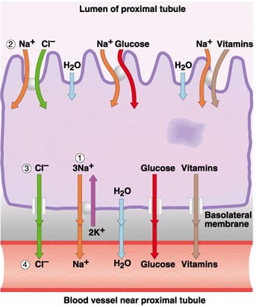

1. **Need lots of surface area thus inner wall of proximal convoluted tubule is lined with microvilli.**

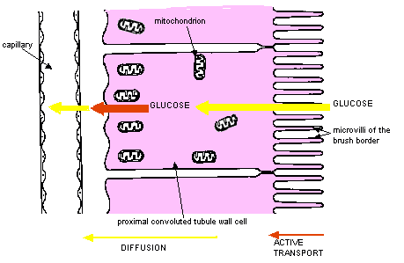

1. **MANY mitochondria in cells lining wall of proximal convoluted tubule … to satisfy high energy needs of active transport.**
2. 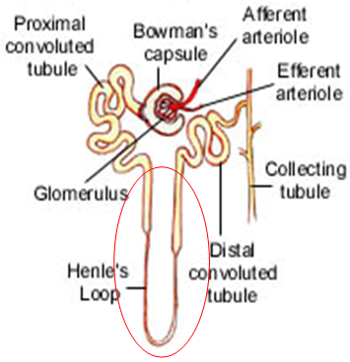**Loop of Henle**

**a. Descending limb:**

**🡪H2O osmoses out due to high Na+ concentration in surrounding tissues.**

**🡪Na+ diffuses into this part of the loop due to concentration gradient.**

***High [Na+] outside the descending limb & low [Na+] inside.***

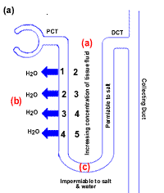

1. **Ascending limb is actively transporting Na+ out into tissues surrounding the loop.**
2. **The ascending limb is NOT permeable to H2O.**

**🡪 thus no H2O enters it from surrounding tissues [even though tissues have water in them…from the descending loop.]**

**This is called countercurrent exchange.**

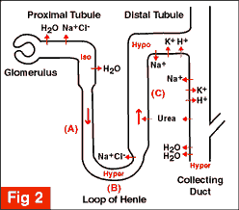

**Urine**

**Video: on loop of Henle** [**http://www.youtube.com/watch?v=_CnhwhHsWLI**](http://www.youtube.com/watch?v=_CnhwhHsWLI)

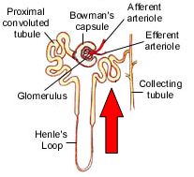

1. **Distal convoluted tubule.**
2. **Na+ actively transported in.**

**🡪 H2O follows it due to osmotic gradient.**

1. **Tubular secretion [DCT only!]**

***Waste substances & molecules which were too large to diffuse out of blood into Bowman’s capsule & tubule at glomerulus are transported from peritubular capillary network into cells of wall of distal conv. tubule.***

**From cells in wall, these molecules are dumped into tubule itself.**

**🡪 All active transport [of course].**

**🡪 Many mitochondria in these cells because of high energy needs of active transport.**

1. **Collecting duct**

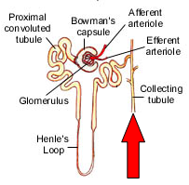

1. **Fluid in here is isotonic with surrounding tissues.**

**🡪 But, duct goes past ascending limb of loop of Henle …  
(which is transporting Na+ out, thus tissues are high in Na+ )**

**…this draws H2O out of the duct.**

**🡪 Fluid in duct *becomes* hypertonic…compared to the tissues.**

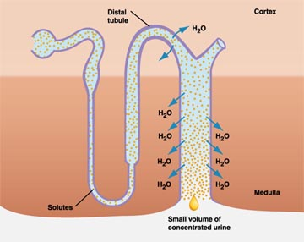

1. **Duct empties into pelvis of kidney and urine goes to bladder for storage until urination time.**

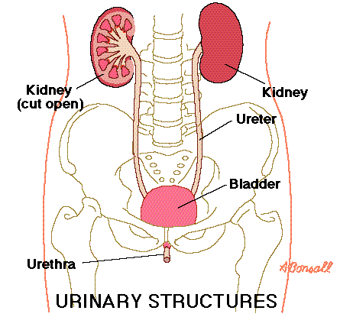

***Don’t forget about the blood in the capillaries. We haven’t discussed what happens to that yet.***

1. **Back at glomerulus…**



1. **…blood in capillaries still carries oxygen & nutrients.**
2. **Capillaries rejoin into efferent arteriole & head towards proximal conv. tubule, loop of Henle, & distal conv. tubule where they rebranch into capillaries.**

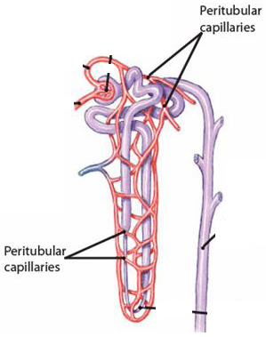

**🡪 RBC’s now lose their O2 & blood loses its nutrients to tissue cells (of kidney to keep its cells alive).**

***… they will, of course, gain CO*2 *from the kidney tissues. at the same time.***

**🡪 they also lose any more wastes to the distal conv. tubule (tubular secretion).** *Text: pages 308, 306, & 305*

1. **These capillaries later rejoin into venules & into the renal vein which returns to the heart…**

***… for pumping to the lungs and back to the heart and on to the body again … etc.***

**Video overview:** [**http://www.youtube.com/watch?v=glu0dzK4dbU**](http://www.youtube.com/watch?v=glu0dzK4dbU)

1. **Hormonal control of blood pressure via antidiuretic hormone**
2. **Posterior lobe of pituitary gland in brain produces antidiuretic hormone (ADH).**

***Anti = against***

***Diuretic = lots of urine***

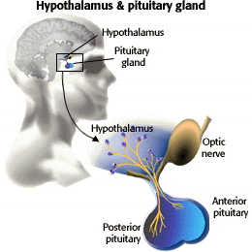

**Text page 326**

1. **ADH causes increased permeability of the distal convoluted tubule (to Na+ exiting) and collecting duct (to H2O exiting).**

**🡪 thus more water LEAVES duct being reabsorbed by kidney tissues & bloodstream.**

**ADH makes your body hold onto H2O…**

**…so less is urinated out.**

**Low fluid intake**

**Loss of fluids**

**Low blood volume**

**Receptors in brain**

**Posterior pituitary releases ADH**

**TEXT p.326 or 329**

**More H2O is reabsorbed   
*(back into blood)***

**Increased permeability**

***(of distal conv. Tubule and collecting duct)***

**ADH  
into blood**

**Increased blood volume**

**Receptors in brain**

***Diarrhoea; diuretics such as alcohol, coffee, or tea; blood loss…***

**LESS water URINATED OUT**

**STOP releasing ADH**

***Volume OK***

***Volume not OK***



1. **Hormonal control of blood pressure via aldosterone**
2. **Low b.p. is detected by cells in juxtaglomerular apparatus {JGA}**



* 1. **These cells secrete *renin* when b.p. is too low to allow proper pressure filtration in glomerulus.**
  2. **Renin changes angiotensinogen into angiotensin I.**
  3. **When angiotensin I in blood arrives at lungs, *angiotensin-converting enzyme* changes angiotensin I into angiotensin II.**
  4. **Angiotensin II is a powerful vasoconstrictor, causing blood vessels all over the body to become narrower.**
  5. **Also, when angiotensin II gets (via bloodstream) to the adrenal cortex it causes the adrenal cortex to release aldosterone.**

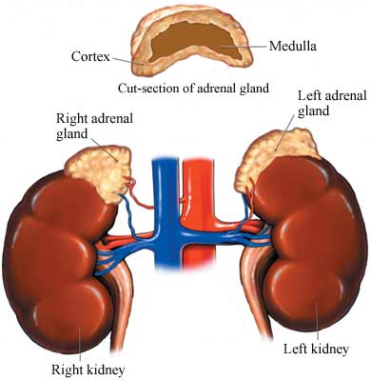

* + 1. **Aldosterone causes reabsorption of sodium ions into the blood at the distal conv. tubule.**
    2. **Aldosterone causes the excretion of potassium ions [K+] at d.c.tubule**
    3. **Increasing sodium in blood causes water to be reabsorbed into blood … leading to increase in blood volume … thus increase in blood pressure.**

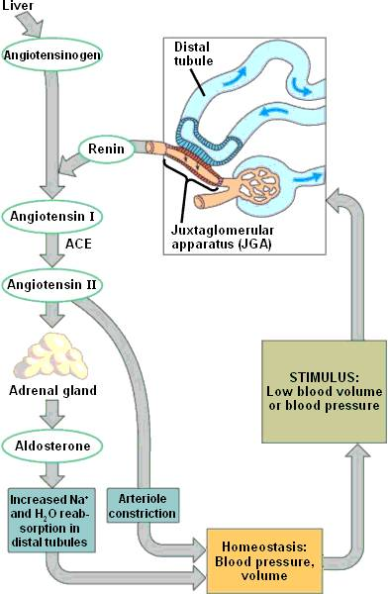

[***http://www.nicerweb.com/bio1152/Locked/media/ch44/44_16KidneyHormoneControl_Aldosterone.jpg***](http://www.nicerweb.com/bio1152/Locked/media/ch44/44_16KidneyHormoneControl_Aldosterone.jpg)

1. **Maintenance of constant blood pH**
2. **The WHOLE nephron is involved.**
3. **Acids: Hydrogen ions (H+) & ammonia (NH3+) are normally excreted *[out of blood into nephron then urinated out]*.**

**Basic sodium ions (Na+) & bicarbonate ions (HCO3-) are normally reabsorbed.**

1. **The kidney can change the proportions of each in order to readjust the pH of your blood.**

e.g. Blood = too acidic, then more hydrogen ions excreted & more sodium ions and bicarbonate ions reabsorbed.

This helps because bicarbonate ions react with water to give hydroxide ions (OH-) …

**Na+HCO3- + H2O 🡪 H2CO3 + Na+OH-**

If blood = too basic, then fewer hydrogen ions excreted and fewer bicarbonate ions and sodium ions reabsorbed.

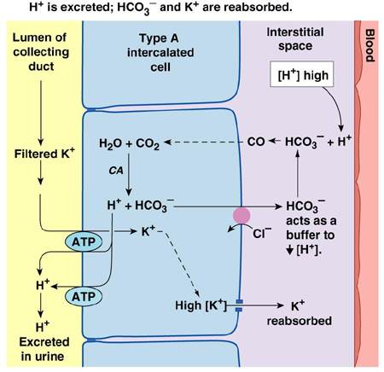

1. **Reabsorption of salt**
2. **Usually, more than 90% of the sodium that leaves the blood at glomerulus is returned to the blood along nephron.**
   1. **67% of this 90% is reabsorbed [into blood] at the PCT.**
      * + *[remember: you also just wrote that “Aldosterone causes reabsorption of sodium ions into the blood at the distal conv. Tubule.”]*
   2. **25% of this 90% is extruded [back into blood] by the ascending limb of the loop of Henle.**
3. **Aldosterone promotes excretion [out of body with urine] of K+ … and reabsorption [into blood] of Na+. [You just wrote this – remember?]**

**…Meaning that aldosterone regulates your salt concentration. [as well as regulating BP]**

**-*Look back at the diagram.***

1. **Atrial natriuretic hormone (ANH)**
2. **Secreted by atria of the heart when cardiac cells are stretched by increased blood volume.**
   1. **ANH inhibits secretion of renin by juxtaglomerular apparatus.**
   2. **ANH also inhibits secretion of aldosterone by adrenal cortex.**
   3. **Altogether this promotes the excretion of Na+ OUT of blood into urine.   
        
      When Na+  is in urine, it draws water into urine   
        
      … so you lose more water**

**… meaning you pee more out  
  
… and end up with lower blood volume.**

**GOOD overview/review video:** [**http://www.youtube.com/watch?v=aQZaNXNroVY&NR=1**](http://www.youtube.com/watch?v=aQZaNXNroVY&NR=1)

**GREAT animation**

**DONE**

****** ☺ ******

[OMG … this will be a nasty test!! So many hormones]

