N. Nervous System

NERVOUS SYSTEM & BRAIN

- Divisions of the nervous system [by humans for ease of reference ]

- Peripheral nervous system. (PNS)

Divided into 2 parts:

→ Somatic nervous system
muscles & body

→ Autonomic nervous system
guts & organs

sympathetic NS
parasympathetic NS

- Central nervous system (CNS)

Spinal cord and brain

B. Peripheral nervous system [PNS]

- PNS nerve cell bodies are next to spinal cord. [protected by spine] Text page 325
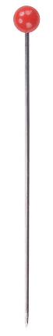
Poke with a pin!
Cell body
Dendrite

b. ganglion: lots of cell bodies together in same place. [ganglia = more than 1 ganglion] Text page 325

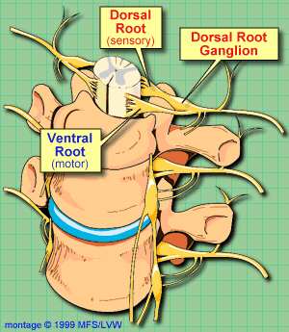

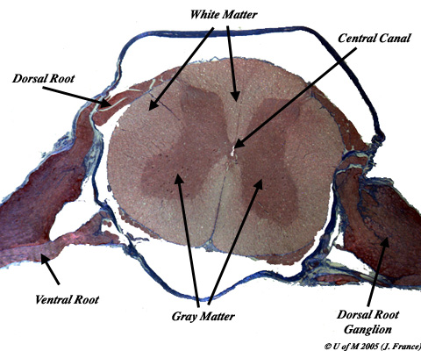

c. PNS nerve cells have L O N G

…long dendrites in sensory nerve cells (take impulses from body to CNS)
And thus these have short axons

…long axons in motor nerve cells (take impulses from CNS to body).
And thus these have short dendrites
Long dendrite
Long axon

- Cranial nerves [I’m still talking about PNS]

- Humans have 12 pairs … attached directly to brain (not spinal cord).

Brain = CNS [not PNS] but cranial nerves are classified as part of PNS.

- 11 pairs of these nerves serve head, face, & neck.
[not of ALL the cranial nerves, but a sample]
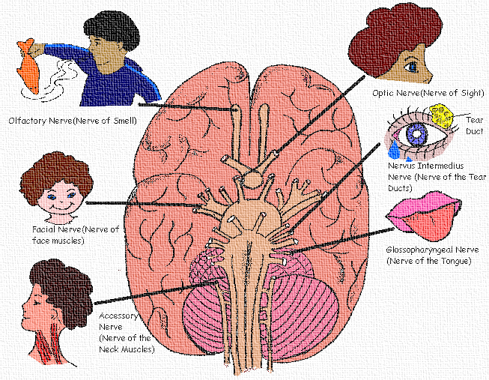

ii. 1 pair = vagus nerve (Besides output to the various organs in the body, the vagus nerve conveys sensory information about the state of the body's organs to the central nervous system. )

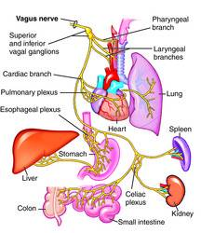

- spinal nerves Text page 334

- one pair for each spine joint [31 pairs].

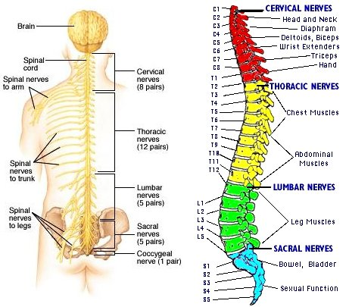

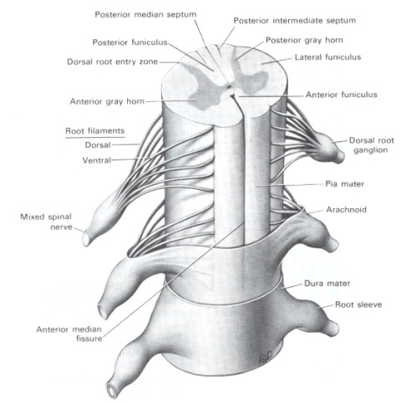
- take impulses to or from brain [brain is CNS]

- these are ‘mixed’ nerves. They have many sensory dendrites and many motor axons.
- somatic nervous system

A division of the PNS, Remember??

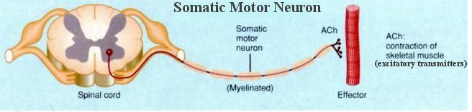

- Includes nerves of musculoskeletal system and sense organs.

- receptor: receives stimulus [a stimulus = info.]
→your 5 senses
- internal organ information

- effector: reacts to stimulus
→e.g. blink, duck, sit, move, smile, walk, talk, laugh, write, chew, …
→ usually a muscle

d. reflex arc [path of a reflex action]

- pathway: page 335 (again)

sensory neuron
motor neuron
interneuron
[in CNS]

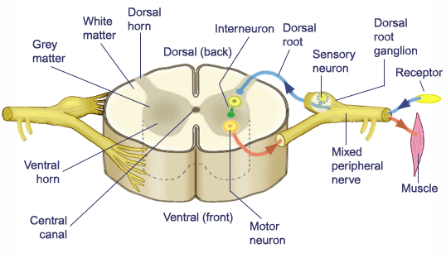

- Quite often a reflex arc goes only to spinal cord & back to muscle…

…rather than going all the way to the brain.

[reduces response time!]

5. Autonomic nervous system

Just another division of the PNS.

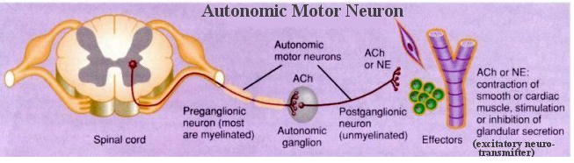

- Made of motor neurons that auto matically control internal organs.

- There are 2 divisions [remember from top of these notes??]
Text page 337
Sympathetic | Parasympathetic
fight or flight | relaxed state
→ inhibits digestion | → promotes digestion
→ dilates pupils | → relaxes pupils
→ increases heart rate | → retards heart rate
* neurotransmitter is NA | * neurotransmitter is ACh
* Another name for noradrenalin is norepinephrine.

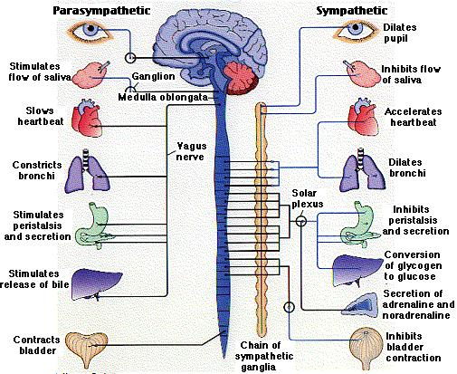

epinephrine norepinephrine

Adrenalin and noradrenalin are
secreted by the adrenal medulla.

Adrenal gland is on your kidney.
[one on each kidney]

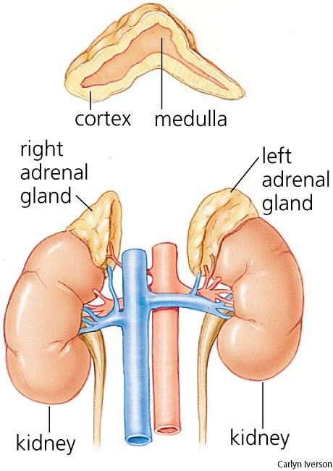

NA [a neurotransmitter] initiates ‘fight-or-flight’ response.

Adrenalin [a hormone] maintains it.

middle

C. Central Nervous System [CNS]

- Includes spinal cord and brain…
Now you know how the disease meningitis got its name.

- Protected by bone
- Wrapped in 3 membranes
→ called the meninges.
- Dura mater is outer layer, Arachnoid is 2nd, & and Pia mater is the 3rd.

→ Cerebrospinal fluid between membrane layers.

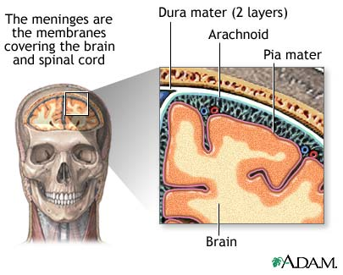

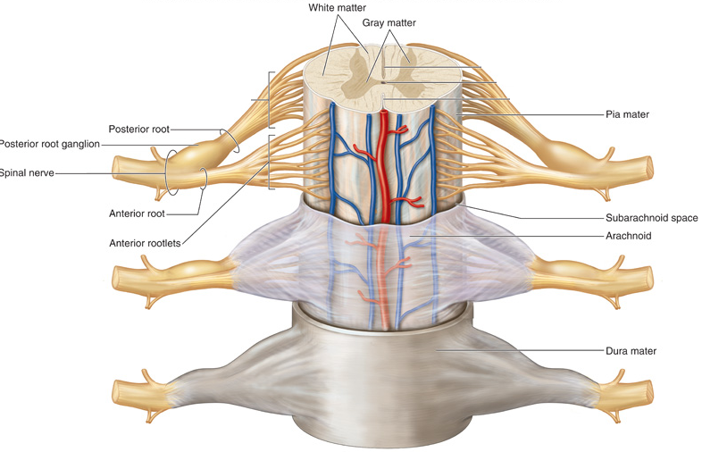

- Spinal cord

- 3 parts

- central canal full of cerebrospinal fluid.

- grey matter (cell bodies & short fibres).

- white matter (long fibres of interneurons).

Grey matter reminds me of a butterfly.

Grey matter receives sensory info. & sends motor info.
White matter carries info. to and from the brain.

* Diagram in text - page 335 shows both types.

- Brain

Has 4 unconscious parts:

- Medulla oblongata
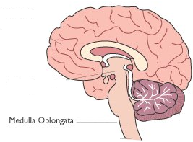
- heart rate
- breathing
- vasoconstriction
[blood pressure]
- reflex centre for:
vomitting
coughing
sneezing
hiccuping
swallowing

- Hypothalamus text pages 329, 326
- homeostasis [has areas to control hunger, thirst, …
…sleep, body temp., H₂O balance, & blood pressure].
- controls pituitary gland

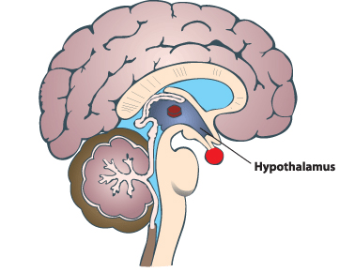
pituitary gland

- Thalamus = “central station” text page 326
- receives ALL sensory impulses (except smell) & sends them where they ought to go.
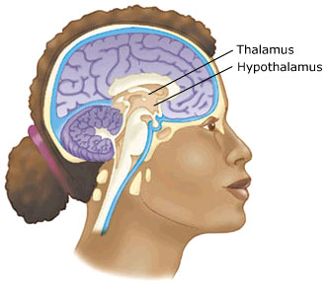

- Cerebellum
- Muscle coordination & body posture.
- balance

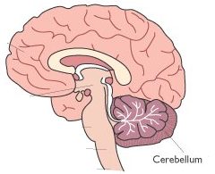

Conscious brain = cerebrum text page 327

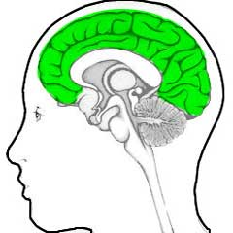

- Divided into 2 halves…

…right hemisphere & left hemisphere.
text page 326
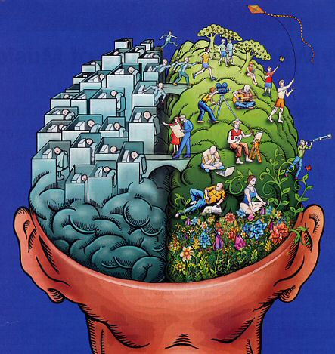

- The halves are joined along the corpus callosum.
- allows sharing of info. between hemispheres.
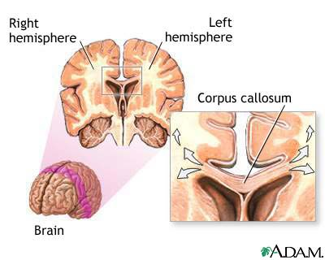
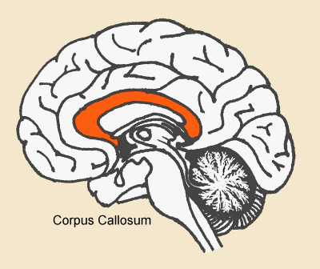

- Each hemisphere has 4 lobes: text page 327

- frontal | - parietal
- temporal | - occipital

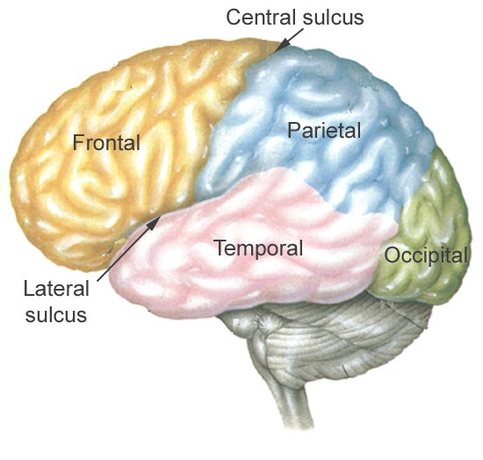

FRONTAL LOBE JOBS: [memorize text information … below is not all inclusive]
- The ability to recognize future consequences resulting from current actions, to choose between good and bad actions (or better and best), override and suppress unacceptable social responses, and determine similarities and differences between things or events. Therefore, it is involved in higher mental functions.
- The frontal lobes also play an important part in retaining longer term memories which are not task-based. These are often memories associated with emotions derived from input from the brain's limbic system. The frontal lobe modifies those emotions to generally fit socially acceptable norms.

Damage to the frontal lobes can lead to a variety of results:
- Mental flexibility and spontaneity are impaired, but IQ is not reduced.
- Talking may increase or decrease dramatically.
- Perceptions regarding risk-taking and rule-abiding are impaired.
- Socialization can diminish or increase.
- Orbital frontal lobe damage can result in peculiar sexual habits.
- Dorsolateral frontal lobe damage reduces sexual interest.
- Creativity is diminished or increased as well as problem solving skills.
- Distraction occurs more frequently.
- Loss of smell and/or taste.

PARIETAL LOBE JOBS: [memorize text information]
- Integrates sensory information, particularly determining spatial sense and navigation. For example, it enables regions of the parietal cortex to map objects seen visually into body coordinate positions.
- Important roles in integrating sensory information from various parts of the body, knowledge of numbers and their relations, and in the manipulation of objects.
- The left hemisphere plays a more prominent role for right-handers and is involved in symbolic functions in language and mathematics. Meanwhile, the right hemisphere plays a more prominent role for left-handers and is specialized to carry out images and understanding of maps i.e. spatial relationships.

- Damage to the right hemisphere of this lobe results in the loss of imagery, visualization of spatial relationships and neglect of left side space and left side of the body. Even drawing may be neglected from the left side.

- Damage to the left hemisphere of this lobe will result in problems in mathematics, long reading, writing and understanding symbols. The parietal association cortex enables individuals to read, write, and solve mathematical problems. The sensory inputs from the right side go to the left side and vice-versa.

OCCIPITAL LOBE JOBS: [memorize text information]
- the visual processing center
- the part of the brain where dreams come from
- It contains a low-level description of the local orientation, spatial-frequency and color properties within small receptive fields

- Damage to the occipital lobe will cause visual distortion or even blindness.

TEMPORAL LOBE JOBS: [memorize text information]
- involved in auditory perception
- It is also important for the processing of semantics in both speech and vision.
- contains the hippocampus and plays a key role in the formation of long-term memory.

Check out this website:
http://science-education.nih.gov/supplements/nih2/addiction/activities/lesson1_brainparts.htm

**** Done Unit N ****

