**J. Blood**

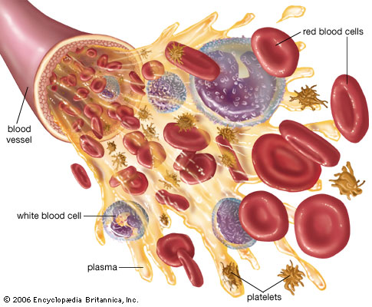

**Jobs of blood: transport important nutrients and gases to body tissues, transport waste gases and waste molecules away, fight infection.**

**Blood components (what blood is made of):**

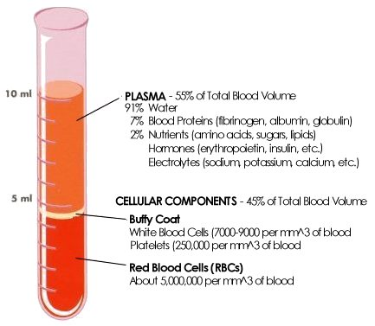*page* ***249*** *of text*

*Fill out the following tables on your own from page 249 and memorize for quiz, test, and provincial.*

|  |  |  |
| --- | --- | --- |
| *FORMED ELEMENT* | *FUNCTION & DESCRIPTION* | *SOURCE* |
| **Red blood cells**  http://www.rkm.com.au/imagelibrary/thumbnails/CELL-Red-Blood-Cell-150.jpg |  |  |
| **Platelets**  http://www.fi.edu/learn/heart/blood/images/blood-platelets.gif |  |  |
| **White blood cells** |  |  |

|  |  |  |
| --- | --- | --- |
| *FOUND IN PLASMA* | *FUNCTION & DESCRIPTION* | *SOURCE* |
| **Water** |  |  |
| **Plasma proteins** |  |  |
| **Salts** |  |  |
| **Gases** |  |  |
| **Nutrients** |  |  |
| **Urea** |  |  |
| **Hormones & vitamins** |  |  |

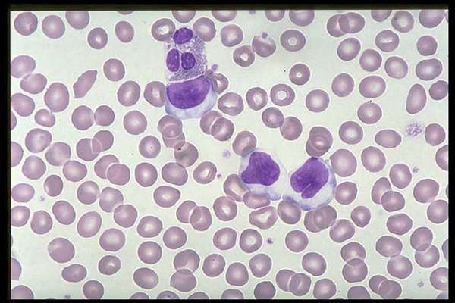

###### Red Blood Cells

**White blood cells**

**Platelets**

1. **Transport I: Blood is transported in vessels.**
2. **Arteries carry blood AWAY from heart.**
3. **Veins carry blood INTO heart  
     
   The pulmonary artery carries BLUISH, DEOXYGENATED blood away to lungs.  
     
   The pulmonary vein carries bright-RED, OXYGENATED blood back into heart.**

[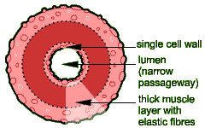](http://compuhigh.com/demo/artery.gif)

*from: compuhigh.com/demo/artery.gif*

**ARTERY STRUCTURE**

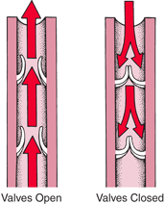

[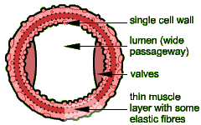](http://compuhigh.com/demo/vein.gif)

*from: compuhigh.com/demo/vein.gif*

**VEIN STRUCTURE**

1. **Capillaries carry blood in tissues where the gasses are being transferred.**
   1. **Blood cells must travel in single file through capillaries … this slows them down and also allows them to drop of their oxygen [and pick up CO2)**

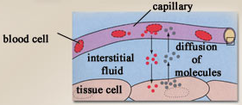

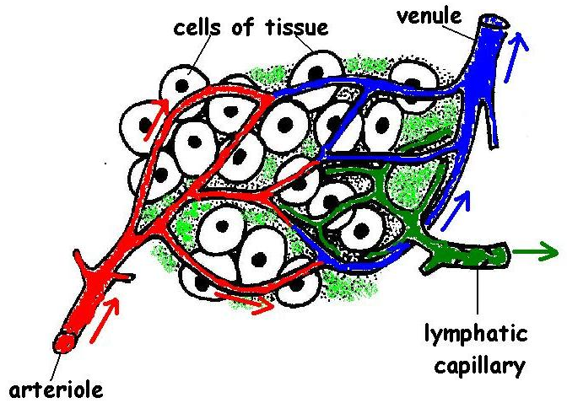

**…🡪 artery 🡪 arteriole 🡪 capillary 🡪 venule 🡪 vein 🡪 heart 🡪 artery 🡪 arteriole 🡪 capillary 🡪 venule 🡪 vein 🡪 heart 🡪 artery 🡪 arteriole 🡪 capillary 🡪 …**

**Video: capillary basics: http://www.youtube.com/watch?v=Q530H1WxtOw**

1. **Transport II : Two paths of blood.**
   1. **Pulmonary circulation: blood *transport*ed from heart to lungs and back to heart. [=pulmonary circuit]**
      1. **Reason for this is to drop off CO2 and pick up O2   
           
         🡪 Right ventricle 🡪 lungs 🡪 left atrium**

*[right bottom] [left top]*

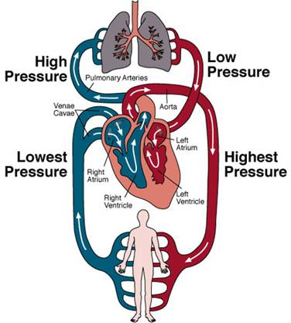

* 1. **Systemic circulation: blood transported from heart to system (body cells) and back to heart. [=systemic circuit]**

**🡪Left ventricle 🡪 body cells 🡪 right atrium**

*[left bottom] [right top]*

1. **Transport III: Blood pressure vs Osmotic pressure**
   1. **Diffusion:**

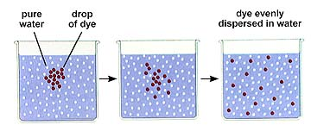

* 1. **Osmosis**

**solution of large molecules**

**semipermeable**

**membrane**

over time

**distilled water**

***\*\*Funnel is uncovered at the top.***

* + 1. **Osmosis: *movement of water from an area of lower solute concentration to an area of higher solute concentration through a semipermeable membrane!***
    2. **Osmotic pressure: pressure created by H2O as it moves during osmosis. 🡪 measured in mmHg.**
  1. **Capillary exchange** *(page 254)*
     1. **The exchange of gases works because the forces of blood pressure & osmotic pressure work opposite to each other.**
     2. **We can MEASURE blood pressure and graph it.**

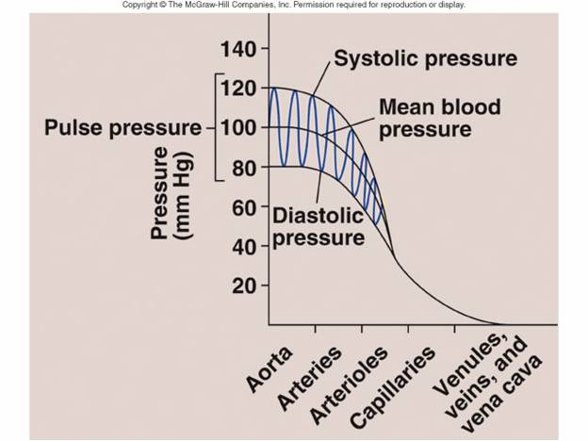

*Page 248*

* + 1. **We can also measure and graph osmotic pressure in the same way.**

120

***Osmotic***

***Pressure***

***(mmHg)***

**veins**

70

21

***Osmotic Pressure is constant throughout the body. (because your solute concentration is not changing all the time … rather your concentration remains constant – it HAS TO.***

**arteries**

**Place or vessel in body**

**capillariess**

0

1. **If we layer the 2 graphs one on top of the other … we get a good explanation of why oxygen LEAVES the blood at the capillaries.**  *[capillaries of body tissues … not lungs]*

120

0

**arteries**

**capillaries**

**veins**

70

21

###### BP

###### OP

**Pressure**

**(mmHg)**

**\*\* Blood pressure is trying to force water OUT of capillaries.**

**\*\* Osmotic pressure is always trying to push water back INTO capillaries.**

1. **Where the 2 graphs cross is IMPORTANT:**

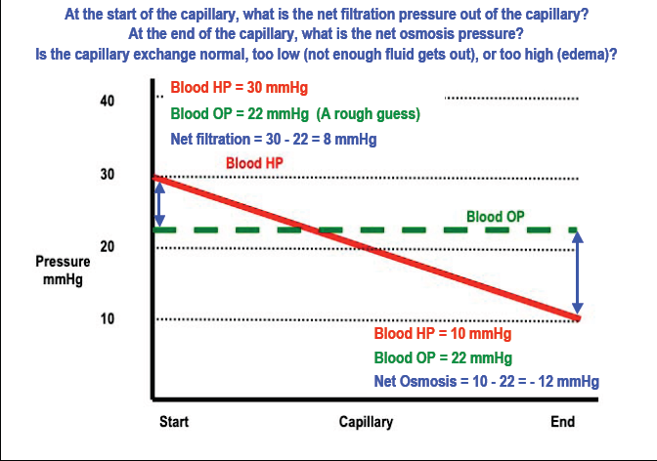

**At arterial side of capillaries:**

**b.p. = 30 mmHg out of capillaries**

**o.p. = 22 mmHg into capillaries**

**b.p. “wins” and water leaves capillaries (drawing oxygen with it) at a pressure of 8 mmHg.**

**[30 – 22 = 8]**

***At venous side of capillaries:***

***b.p. = 10 mmHg out of capillaries***

***o.p. = 22 mmHg into capillaries***

***o.p. “wins” and water enters capillaries (drawing carbon dioxide with it) at a pressure of 12 mmHg.***

***[10 – 22 = -12)***

**\*\* Notice how the pressures of water entering or leaving are different. There is a net loss of fluid from the blood in the capillary. This lost fluid is picked up by the lymph system and returned to the blood stream later.** *[page 254]*

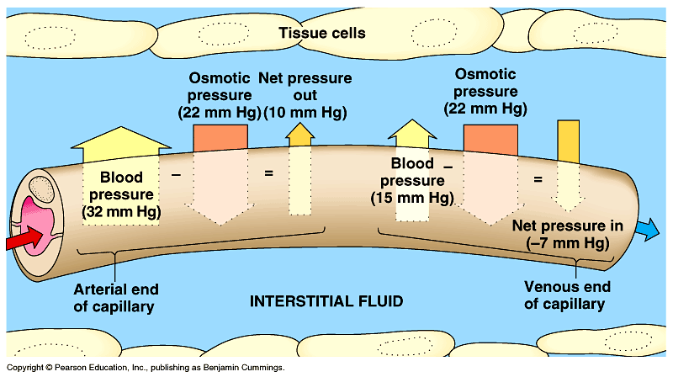

**Go to:** [**http://www.innerbody.com/anim/blood.html**](http://www.innerbody.com/anim/blood.html)

1. **Transport IV: Blood Clotting (or…how holes in the transport tubes are plugged and fixed)**

http://whatcausesbloodclots.com/

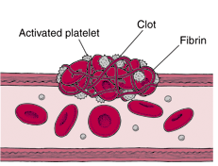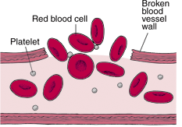

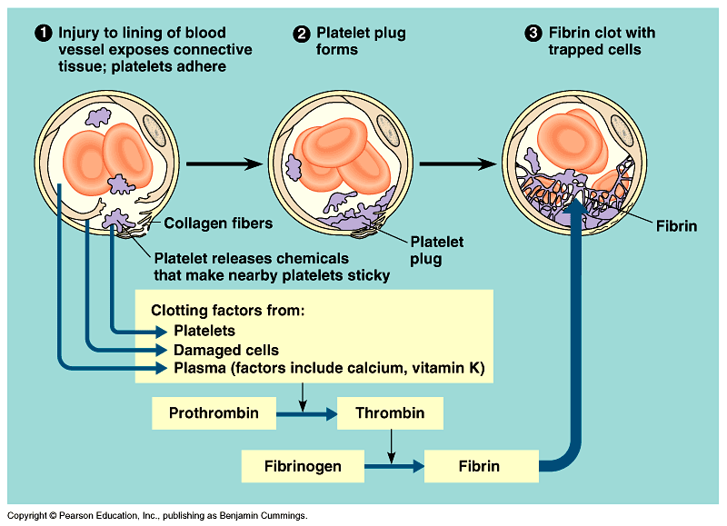

[***http://www.pcsd.k12.ny.us/bwoods/Regents%20Biology/Chapter%2010%20Blood%20and%20Immunity/42-16-BloodClotting-L.gif***](http://www.pcsd.k12.ny.us/bwoods/Regents%20Biology/Chapter%2010%20Blood%20and%20Immunity/42-16-BloodClotting-L.gif)

**1. overview**

vessel

damaged

platelets clump in the hole (slow the bleeding)

platelets & injured tissues release prothrombin activator (an enzyme)

***causes***

prothrombin thrombin ***(an enzyme)***

***Ca++ required***

***causes***

Made by the liver

fibrinogen fibrin

**(threads)**

wind around

platelet plug

RBC’s also get trapped in the fibrin threads … that’s why a scab is red!

**2. Extra and important details:**

* + 1. **Platelets stick to exposed collagen proteins.**
    2. **Causes the release of:**

**🡪 ADP (adenosine diphosphate)**

**🡪 serotonin**

**🡪 prostaglandins**

**🡪 phospholipids**

* + 1. **serotonin and prostaglandin cause vasoconstriction. (vessel diameter reduces to slow flow of blood).**
    2. **ADP makes platelets ‘sticky’ so new platelets stick to the ones stuck to the collagen.  
         
       [This is what causes formation of the plug]**
    3. **Fibrin web [completes the seal of the rip in the vessel].**

**Video:** [***http://www.youtube.com/watch?v=HFNWGCx_Eu4***](http://www.youtube.com/watch?v=HFNWGCx_Eu4)

**3. intrinsic pathway (response of blood to the injured vessel)**

**🡪 phospholipids (from platelets, remember), calcium ions (Ca++) & other activators convert prothrombin into thrombin.**

**🡪 thrombin is a protease that converts fibrinogen into fibrin.**

**\* fibrin polymerises (forms long threadlike molecules)**

**\* fibrin threads stick to damaged surface of a blood vessel.**

**\* fibrin web traps blood cells & more platelets … making clot stronger & preventing leaks.**

1. **Extrinsic pathway (response of tissues to the injury)**

**🡪 damaged tissue cells release tissue thromboplastin.**

**🡪 thromboplastin, phospholipids & Ca++ convert prothrombin into thrombin.**

**🡪 thrombin converts fibrinogen into fibrin.**

1. **Dissolving of clots.**

**\*\* Scab will fall off when SKIN is healed, but clot on inside of vessel needs to be dissolved after healing finishes or it could trap more stuff or dislodge and cause a stroke, pulmonary embolism, or heart attack if it gets stuck somewhere.**

* + 1. **As damaged blood vessel wall is repaired:  
         
       plasminogen plasmin**
    2. **Plasmin is an enzyme that digests fibrin.**

1. **Inflammatory response**

**Whenever skin or tissue is damaged the area becomes reddened and swells. (Inflammatory response).**

*See page 265***.**

* 1. **Capillary and tissue cells rupture and release histamine and bradykinin.**
  2. **histamine (released by mast cells) causes capillary to dilate (bigger around) and become more permeable.**
  3. **Proteins and fluids leak out (causing swelling).**
  4. **Amoeboid cells (neutrophils and monocytes) leak out of capillary, too, and start killing germs. Monocytes will phagocytize the germs.**
  5. **Dilated capillaries make skin red.**
  6. **bradykinin enhances histamine’s effects and also initiates nerve impulses causing pain sensation.**
  7. 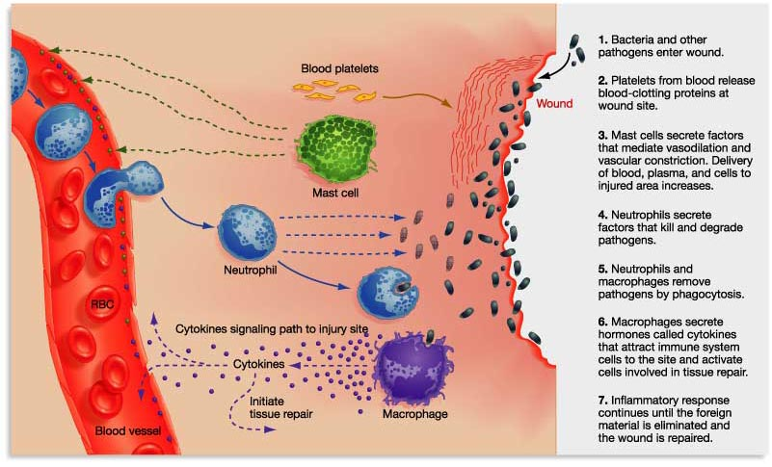**Dead neutrophils, dead tissue, dead cells, dead bacteria, and living white blood cells form pus … indicating that the body is trying to overcome the infection.**

**Video: #1: short animation low on detail [1 min]** [**http://www.youtube.com/watch?v=CmbWE3jLUgM**](http://www.youtube.com/watch?v=CmbWE3jLUgM)

**#2: longer, stop action, more detail. 4 min:** [**http://www.youtube.com/watch?v=_bNN95sA6-8**](http://www.youtube.com/watch?v=_bNN95sA6-8)

1. **Infection fighting**
   1. **Your blood also has antibodies in it.** *(Go up to top of blood notes and add this information)*

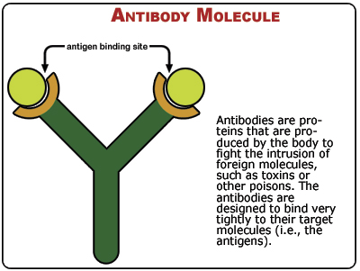

* + - * 1. **Antibody: a protein (shape matters, here too!) your body produces to bind to and get rid of an antigen.**
        2. **Antigen: a foreign substance in your blood (usually a protein) that your immune system reacts to.**

**🡪Virus particles, bacteria, pollen, the wrong blood type**

* + - 1. **When an antigen enters your body your body will make antibodies to fight it.** 
         1. **It takes time to make specific antibodies.**
         2. **B lymphocytes make plasma cells which produce antibodies. They flow around the circulatory system.**

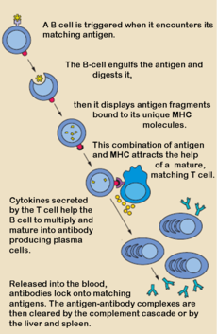

* + - 1. **Antibodies work by binding to specific proteins on the antigen.**
      2. **The antibody-antigen complex is then attacked and phagocytized [eaten] by T lymphocytes. WBC’s**

*Text page 267*

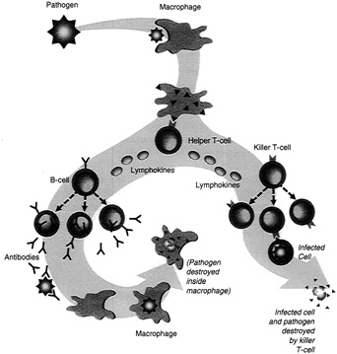

**Video:** [**http://www.youtube.com/watch?v=Ys_V6FcYD5I**](http://www.youtube.com/watch?v=Ys_V6FcYD5I)

1. **Lymphatic system (recollection of leaked out fluids, infection fighting, AND absorption of fats from digestive system)**
   1. **Recollection of leaked out fluids**
      1. **Invariably, some of the plasma does leak out of your blood at the capillaries. Also, you swell up when you sleep and when you get bruised, bumped or injured. This swelling must be removed and the plasma must be reabsorbed.**
      2. **Lymph capillaries are all over your body and collect back fluids.** *Text page 262*

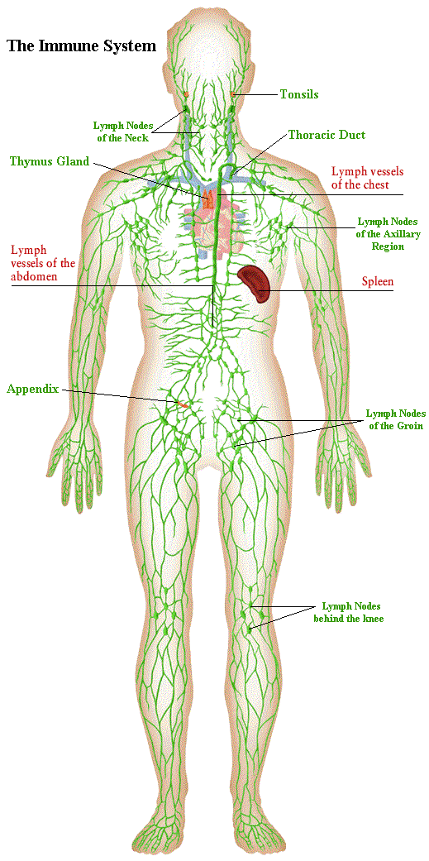

* + 1. **Lymph veins (there are no lymph arteries) are what lymph capillaries join together into.**
  1. **There is no pump for lymph. It moves back to “drain” into blood vessels just by your skeletal muscles squeezing.**
     + - 1. **Lymph veins have valves to prevent backflow.**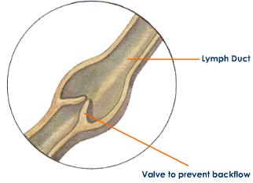
         2. **Lymph drains back into your bloodstream at right lymphatic duct in right subclavian vein and thoracic duct into left subclavian vein in thorax.**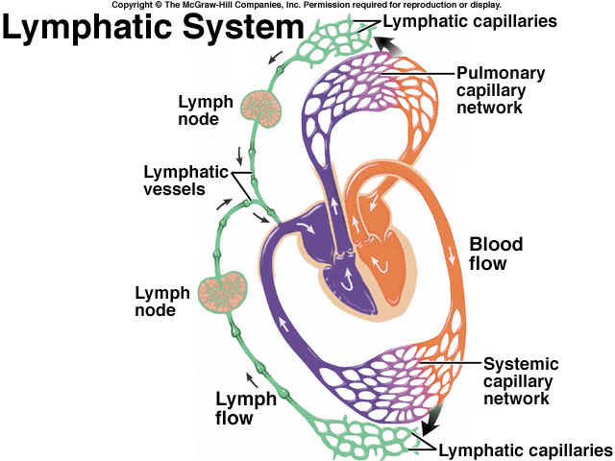
  2. **Lymph nodes: macrophages in them purify lymph as it passes through. Get rid of microbes and debris.**

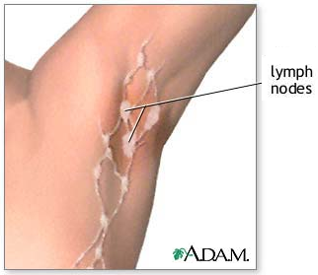

* 1. **Absorption of fats into lacteals of small intestine. *(Remember??)***

**Video:** [**http://www.youtube.com/watch?v=lGRceUoQRVw&feature=related**](http://www.youtube.com/watch?v=lGRceUoQRVw&feature=related)

**Reminder: Major blood vessels to know:** *[see your text p.246 & 247!]*

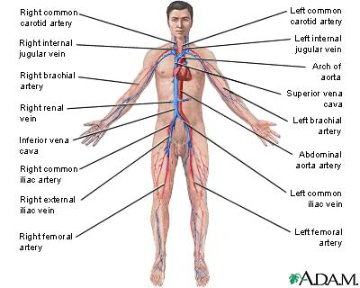

**\*\*\* DONE Unit J \*\*\***